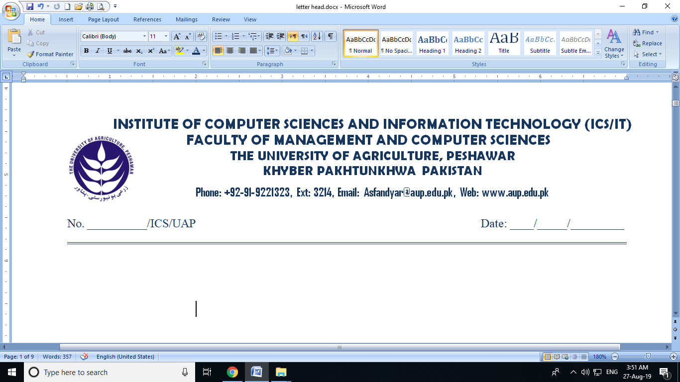

**BOS SYNOPSIS CORRECTION CERTIFICATE**

It is certified that Mr /Mrs. ___________________________ student of MS_______ under Class No ________ Session ________________has corrected his / her synopsis as according to the minutes of board of study (BOS# ______ ) held on ____/___ /______.

**_____________________________**

**Chairman Supervisory Committee**

**Correction Endorsement Committee:**

Name: ____________________________ Signature: __________________

**Incharge / Coordinator**

**Post-Graduate ICS/IT (FMCS)**

**______________________________________________________________________________**

* **The following documents must be attached for Synopsis BOS Corretion Certificate:**

1. Photocopy of current semester Registration Form with Bank Slip.
2. Photocopy of Supervisory Committee Notification.
3. Minutes of Synopsis BOS meeting. (available Dealing Assistant)
4. Approved Correction Certificate (Signed by Endorsement Committee & Major Supervisor ) (available at aupcsit.web.app)
5. Rough Plagiarism Certificate of Synopsis Title Name + Major Supervisor Name +Student Name & Roll No. (Signed by Major Supervisor) bind at the end of each copy.
6. **Four (04)** copies of Synopsis (duly signed by supervisory committee) in tape binding.